
A Project-2 Report on,
Comparative Evaluation of Data Normalization Techniques for Non-Gaussian Biomedical Signal Datasets
By,
Aakash Vishvanath Bhosale
(SRN: 31240150)
Guided By
Dr. Anupriya Kamble
Course Name: Research Methodology
For the Programme
B.Sc. - COMPUTER SCIENCE
Third Year
In the Year
2026-27
Pursued in
Department of Computer Science
Faculty of Science & Technology
Vishwakarma University, Pune
CERTIFICATE
This is to certify that the work incorporated in the Project entitled “Comparative Evaluation of Data Normalization Techniques for Non-Gaussian Biomedical Signal Datasets” submitted to Vishwakarma University, Pune by Aakash Vishvanath Bhosale (SRN: 31240150) for the completion of the course Research Methodology of course code BSCCS24504 / MT24CS04 was carried out by him under my supervision in the Department of Computer Science, Faculty of Science and Technology, Vishwakarma University, Pune, Maharashtra, India. This work was not previously submitted by him to this or any other University for the award of any Degree, Diploma, Associateship or any other similar title.
Place: Pune | Dr. Anupriya Kamble
Date: Thursday, October 29, 2026 | Course Coordinator
DECLARATION
I hereby declare that the present research work in the form of project report entitled “Comparative Evaluation of Data Normalization Techniques for Non-Gaussian Biomedical Signal Datasets”, is an original work carried out by me under the guidance of Dr. Anupriya Kamble, Assistant Professor, Department of Computer Science, Faculty of Science and Technology, Vishwakarma University, Pune, Maharashtra, India for the completion of the course Research Methodology.
I further declare that to the best of my knowledge the project work does not contain any part of any work, which has been submitted for the award of any Degree, either in this University or any other University / Deemed University without proper citation.
I further declare that the material referred from other sources has been duly acknowledged in the project report.
Place: Pune | Aakash Vishvanath Bhosale
Date: 29th October 2026 | SRN: 31240150 (Third Year B.Sc. CS)
ABSTRACT
Physiological telemetry such as the electrocardiogram (ECG) and electroencephalogram (EEG) produces features that are strongly asymmetric and heavy-tailed: inter-beat variability, spectral band power and line-length measures are bounded below by zero, right-skewed and contaminated with artefact-driven outliers. Many classifiers, including support-vector machines, k-nearest neighbours and regularised linear models, implicitly assume features of comparable scale and, in some cases, approximately symmetric distributions, so the choice of normalization step can materially change diagnostic performance. This project presents a controlled, reproducible comparison of three widely used feature scaling families on asymmetric biomedical signal features: Min-Max scaling, Quantile Transformation (to uniform and to normal outputs) and the Box-Cox power transformation.
Two benchmark feature sets were constructed in Python: an ECG set of 1,200 beat-window records and an EEG set of 1,200 epochs, each with eight log-normal, gamma, exponential or beta distributed features and a binary clinical label (arrhythmic versus normal; seizure-like versus background). Each technique was assessed on distributional criteria (mean absolute skewness, excess kurtosis, Shapiro-Wilk W, tail outlier rate, class separability measured by Cohen’s d) and on downstream classification (Logistic Regression, RBF-SVM and KNN under stratified 5-fold cross-validation, with every scaler fitted inside the training folds to avoid data leakage).
Raw features had a mean absolute skewness of 2.03 (ECG) and 2.33 (EEG). Min-Max scaling left the shape unchanged, whereas Quantile and Box-Cox transformation reduced it to below 0.02 and raised Shapiro-Wilk W from about 0.83 to above 0.99. Any scaling improved mean accuracy over raw features by roughly 5 to 7 percentage points (83.8% to 90.8% for ECG; 83.6% to 89.1% for EEG), with Box-Cox obtaining the highest mean accuracy on both datasets. The gap among the three leading methods was smaller than the fold-to-fold standard deviation, so the practical recommendation is guided by data properties rather than by a single winner.
INDEX
Sr. No. | Content | Pg. No.
1. | Introduction | 6
 | 1.1 Objective | 6
 | 1.2 Novel Idea | 6
 | 1.3 Significance | 6
 | 1.4 Specifications | 6
2. | Literature Survey | 8
3. | Methodology | 9
4. | Implementation | 10
 | 4.1 Architecture and Data Structures | 10
 | 4.2 Core Normalization and Evaluation Logic | 10
 | 4.3 Complete Application Source Code | 10
 | 4.4 Experimental Results & Output Telemetry | 12
5. | Conclusion and Future Scope | 16
 | 5.1 Conclusion | 16
 | 5.2 Future Scope | 16
6. | References | 17
1. Introduction
1.1 Objective:
The primary objective of this project is to carry out a systematic, comparative evaluation of data normalization techniques for non-Gaussian biomedical signal datasets. Specifically, the project evaluates Min-Max scaling, Quantile Transformation and the Box-Cox power transformation on asymmetric ECG and EEG feature sets, and quantifies (i) how well each technique reshapes or preserves the feature distributions, (ii) how much class-discriminative structure survives the transformation, and (iii) how each technique affects the accuracy of standard classifiers when used as a pre-processing step inside a leakage-free cross-validation pipeline.
1.2 Novel Idea:
Normalization is usually treated as a routine pre-processing line (“scale the data”) and is rarely benchmarked on its own, particularly for physiological data whose features are skewed by physics and by artefacts rather than by sampling noise. This project contributes four elements:
- Distribution-aware comparison: scalers are judged on skewness, kurtosis, Shapiro-Wilk W and tail-outlier rate, not only on final classifier accuracy.
- Separability preservation: Cohen’s d between the clinical classes is computed before and after every transformation to check that the scaling does not erode the diagnostic signal.
- Leakage-free protocol: every scaler is placed inside a scikit-learn Pipeline so that its parameters (minimum, maximum, quantiles or Box-Cox λ) are estimated only on the training folds of each cross-validation split.
- Two modalities, three learners: the same protocol is applied to ECG and EEG features and to three classifiers with different sensitivity to feature scale (Logistic Regression, RBF-SVM and KNN).
1.3 Significance:
Cardiac and neurological monitoring increasingly relies on machine learning models trained on features extracted from wearable and bedside telemetry. Such features (heart-rate-variability indices, band power, line length) are almost never Gaussian. An inappropriate normalization step can compress the informative bulk of a distribution into a tiny interval (as Min-Max scaling does when a single artefact stretches the range), distort relative distances used by KNN and SVM, or destabilise optimisation for linear models. Clear, evidence-based guidance on which scaler to use for which data property reduces avoidable performance loss, makes published pipelines easier to reproduce, and supports the preparation of the work for submission to an indexed venue in medical informatics.
1.4 Specifications:
- Operating System & Development Environment: Windows 10/11 and Linux (Ubuntu), VS Code, Python virtual environment.
- Programming Language & Runtime: Python 3.11+ (NumPy, pandas, SciPy). MATLAB is identified as the reference environment for cross-validation of the Box-Cox and quantile routines (see Future Scope).
- Machine-Learning Libraries: scikit-learn 1.8 (MinMaxScaler, QuantileTransformer, PowerTransformer, LogisticRegression, SVC, KNeighborsClassifier, StratifiedKFold, Pipeline).
- Statistics & Visualisation: SciPy 1.17 (skew, kurtosis, Shapiro-Wilk, probplot) and Matplotlib for the four diagnostic figures.
- Datasets: two synthetic benchmark feature sets, ECG_features.csv and EEG_features.csv (1,200 rows × 8 features + binary label each), generated with a fixed random seed (42) for full reproducibility.
- Evaluation Protocol: stratified 5-fold cross-validation (seed 7); metrics are accuracy and F1-score (positive class = pathological).
2. Literature Survey
The statistical case for power transformations was made by Box and Cox (1964), who proposed a one-parameter family of monotone transformations whose parameter λ is chosen by maximum likelihood so that the transformed variable is as close to normal as possible. Sakia (1992) reviewed the technique and its practical limits, notably the requirement that the variable be strictly positive. Yeo and Johnson (2000) later extended the idea to variables with zero or negative values, and these methods now form the basis of the PowerTransformer available in scikit-learn (Pedregosa et al., 2011).
Normalization has been studied extensively in pattern recognition. Jain, Nandakumar and Ross (2005) compared Min-Max, z-score, median-MAD, double-sigmoid and tanh normalization for score fusion in multimodal biometric systems and showed that robustness to outliers is the deciding property of a good scaler. Singh and Singh (2020) investigated the impact of fourteen normalization methods on classification performance across several classifiers and datasets, concluding that the effect depends strongly on the learner and on the data. Peterson and Cavanaugh (2020) introduced ordered quantile normalization, a rank-based, semi-parametric transformation designed to be fitted inside cross-validation folds, which is conceptually the Quantile Transformation evaluated here. Hastie, Tibshirani and Friedman (2009) explain why distance-based and kernel methods in particular are sensitive to the relative scale of inputs.
On the biomedical side, the Task Force of the European Society of Cardiology and the North American Society of Pacing and Electrophysiology (1996) defined the standard time- and frequency-domain heart-rate-variability measures (such as RMSSD and the LF/HF ratio), many of which are inherently right-skewed. The MIT-BIH Arrhythmia Database (Moody and Mark, 2001), distributed through PhysioNet (Goldberger et al., 2000), is the standard benchmark for ECG classification, and Andrzejak et al. (2001) released a widely used EEG corpus that distinguishes healthy, interictal and seizure activity. Band-power and line-length features derived from such recordings are typically log-normal or gamma distributed.
Despite this body of work, normalization is typically reported as an unexamined detail in ECG and EEG classification papers. The present project fills this gap with a controlled head-to-head comparison that separates the effect on feature distributions from the effect on classifier accuracy, using a protocol that prevents information leakage from test folds. Implementation relies on NumPy (Harris et al., 2020), SciPy (Virtanen et al., 2020), scikit-learn and Matplotlib (Hunter, 2007).
3. Methodology
The study follows a five-stage deterministic pipeline designed for transparency and reproducibility:
Stage 1: Benchmark Feature Construction.
Two feature sets were generated with NumPy’s default_rng(42). The ECG set contains 1,200 beat-window records with eight features: RR_mean, RR_std, QRS_width, R_amp, HRV_RMSSD, QT_interval, T_wave_amp and Spectral_LF_HF. The label is arrhythmic (prevalence parameter 0.35) or normal. The EEG set contains 1,200 epochs with eight features: delta, theta, alpha and beta power, line_length, kurtosis_raw, spectral_entropy and zero_cross_rate, labelled seizure-like (prevalence 0.40) or background. Feature distributions are log-normal, gamma, exponential, beta or (for QT_interval) near-normal, with class-dependent parameters so that the pathological class is shifted and more dispersed. This yields strongly asymmetric, strictly positive features with a realistic degree of class overlap.
Stage 2: Normalization Techniques under Test.
- Min-Max scaling: x′ = (x − x_min) / (x_max − x_min), an affine map to [0, 1] that preserves the shape of the distribution exactly but is sensitive to extreme values.
- Quantile Transformation: x′ = F̂(x), where F̂ is the empirical cumulative distribution estimated from 200 quantiles, producing a uniform output; with the normal option the output is Φ⁻¹(F̂(x)), a standard normal. Both are monotone and robust to outliers.
- Box-Cox power transformation: x(λ) = (x^λ − 1) / λ for λ ≠ 0 and ln x for λ = 0, with λ estimated per feature by maximum likelihood and the output standardised to zero mean and unit variance. It requires x > 0, which holds for all features here.
Stage 3: Distributional Assessment.
For every dataset and method the following were computed over the eight features: mean absolute skewness, mean absolute excess kurtosis, mean Shapiro-Wilk W (first 500 samples; W = 1 indicates normality), the percentage of points beyond three standard deviations, and the mean absolute Cohen’s d between the two clinical classes, d = |μ₁ − μ₀| / √((σ₁² + σ₀²)/2), as a measure of preserved class separability.
Stage 4: Leakage-Free Classification.
Each scaler was combined with each classifier in a scikit-learn Pipeline and evaluated with stratified 5-fold cross-validation, so that scaler parameters are learned from training folds only. Classifiers: Logistic Regression (max_iter = 2000), SVM with RBF kernel (C = 1, gamma = “scale”) and KNN (k = 7). Reported metrics are mean accuracy, its standard deviation across folds, and mean F1-score for the pathological class. A raw (unscaled) baseline is included for reference.
Stage 5: Visual Diagnostics and Reporting.
Histograms, skewness bars, grouped accuracy bars and normal Q-Q plots were produced to visualise the effect of each transformation, and all numerical results were exported to CSV for traceability.
4. Implementation
4.1 Architecture and Data Structures:
The implementation is a single reproducible Python script (experiment.py) organised into five logical blocks:
- make_ecg() / make_eeg(): generate the two feature DataFrames and label vectors from fixed-seed random generators.
- make_scaler(name): factory returning a MinMaxScaler, QuantileTransformer (uniform or normal output, 200 quantiles) or PowerTransformer(method=“box-cox”), or None for the raw baseline.
- Distribution metrics loop: fits each scaler and records skewness, kurtosis, Shapiro-Wilk W, outlier percentage and Cohen’s d into the DataFrame dist (exported as dist.csv).
- Cross-validation loop: builds make_pipeline(scaler, classifier) for each dataset × method × model combination (30 combinations) and stores accuracy, standard deviation and F1 in clf (clf.csv).
- Figure generation: produces fig1 to fig4 with Matplotlib.
4.2 Core Normalization and Evaluation Logic:
The decision rules that govern the experiment are summarised below.
- Leakage control: scalers are never fitted on the full dataset for classification; they are fitted inside each training fold through the Pipeline. (The descriptive distribution statistics in Table 1 are computed on the full dataset purely for description.)
- Strict positivity: Box-Cox is applied only because every feature is greater than zero; for features containing zeros or negatives, Yeo-Johnson or Quantile Transformation should be used.
- Monotonicity: all three methods are monotone per feature, so the within-feature rank order is preserved; differences arise only in spacing between values, which is what distance- and margin-based learners are sensitive to.
- Selection criterion: methods are compared on mean accuracy across the three classifiers, with fold-to-fold standard deviation used to judge whether differences are meaningful.
4.3 Complete Application Source Code:
The complete experiment script (data generation, normalization, metrics and cross-validation) is listed below; the figure-plotting code is omitted for brevity.
import numpy as np, pandas as pd, json, warnings
import matplotlib; matplotlib.use("Agg")
import matplotlib.pyplot as plt
from scipy import stats
from sklearn.preprocessing import MinMaxScaler, QuantileTransformer, PowerTransformer
from sklearn.model_selection import StratifiedKFold, cross_validate
from sklearn.pipeline import make_pipeline
from sklearn.linear_model import LogisticRegression
from sklearn.svm import SVC
from sklearn.neighbors import KNeighborsClassifier
from sklearn.metrics import make_scorer, f1_score
warnings.filterwarnings("ignore")
rng = np.random.default_rng(42)

def make_ecg(n=1200):
y = rng.binomial(1, 0.35, n) # 1 = arrhythmic
f = {}
f["RR_mean"] = np.where(y, rng.lognormal(-0.35,0.35,n), rng.lognormal(-0.20,0.18,n))
f["RR_std"] = np.where(y, rng.lognormal(-2.3,0.7,n), rng.lognormal(-3.2,0.5,n))
f["QRS_width"] = np.where(y, rng.gamma(6,0.017,n), rng.gamma(9,0.010,n))
f["R_amp"] = np.where(y, rng.lognormal(0.0,0.55,n), rng.lognormal(0.25,0.35,n))
f["HRV_RMSSD"] = np.where(y, rng.lognormal(-2.6,0.8,n), rng.lognormal(-3.3,0.55,n))
f["QT_interval"] = rng.normal(0.40,0.03,n) + 0.03*y
f["T_wave_amp"] = np.where(y, rng.exponential(0.30,n), rng.exponential(0.18,n))
f["Spectral_LF_HF"] = np.where(y, rng.lognormal(0.9,0.8,n), rng.lognormal(0.3,0.6,n))
return pd.DataFrame(f), y

def make_eeg(n=1200):
y = rng.binomial(1, 0.40, n) # 1 = seizure-like
f = {}
f["delta_power"] = np.where(y, rng.lognormal(3.4,0.8,n), rng.lognormal(2.7,0.6,n))
f["theta_power"] = np.where(y, rng.lognormal(2.9,0.7,n), rng.lognormal(2.4,0.6,n))
f["alpha_power"] = np.where(y, rng.lognormal(2.0,0.8,n), rng.lognormal(2.5,0.6,n))
f["beta_power"] = np.where(y, rng.lognormal(2.4,0.7,n), rng.lognormal(1.9,0.6,n))
f["line_length"] = np.where(y, rng.gamma(2.2,40,n), rng.gamma(3.0,18,n))
f["kurtosis_raw"] = np.where(y, rng.lognormal(1.5,0.5,n), rng.lognormal(1.1,0.35,n))
f["spectral_entropy"] = np.where(y, rng.beta(5,2.2,n), rng.beta(4,3.5,n))
f["zero_cross_rate"] = np.where(y, rng.gamma(4,0.02,n), rng.gamma(5,0.03,n))
return pd.DataFrame(f), y

datasets = {"ECG": make_ecg(), "EEG": make_eeg()}
def make_scaler(name):
return {"None (raw)": None,
"Min-Max": MinMaxScaler(),
"Quantile (uniform)": QuantileTransformer(n_quantiles=200, output_distribution="uniform", random_state=0),
"Quantile (normal)": QuantileTransformer(n_quantiles=200, output_distribution="normal", random_state=0),
"Box-Cox": PowerTransformer(method="box-cox", standardize=True)}[name]
methods = ["None (raw)","Min-Max","Quantile (uniform)","Quantile (normal)","Box-Cox"]

# --- distribution metrics (fit on whole set for descriptive purposes) ---
rows=[]
for dn,(X,y) in datasets.items():
for m in methods:
sc = make_scaler(m)
Z = X.values if sc is None else sc.fit_transform(X.values)
sk = np.abs(stats.skew(Z,axis=0)).mean()
ku = np.abs(stats.kurtosis(Z,axis=0)).mean()
sw = np.mean([stats.shapiro(Z[:500,j])[0] for j in range(Z.shape[1])])
# distribution preservation: mean Spearman rank corr w/ original (monotonic => 1) and class separation (mean |Cohen d|)
d = np.mean([abs((Z[y==1,j].mean()-Z[y==0,j].mean())/np.sqrt((Z[y==1,j].var()+Z[y==0,j].var())/2)) for j in range(Z.shape[1])])
# outlier fraction beyond 3 sd
zz=(Z-Z.mean(0))/Z.std(0); out=(np.abs(zz)>3).mean()*100
rows.append(dict(Dataset=dn,Method=m,MeanAbsSkew=sk,MeanAbsExcessKurt=ku,ShapiroW=sw,CohenD=d,OutlierPct=out))
dist = pd.DataFrame(rows)

# --- classification, scaler fit inside CV folds (no leakage) ---
skf = StratifiedKFold(5, shuffle=True, random_state=7)
models = {"LogReg": LogisticRegression(max_iter=2000),
"SVM-RBF": SVC(C=1.0, gamma="scale"),
"KNN (k=7)": KNeighborsClassifier(7)}
sc_f1 = make_scorer(f1_score)
crow=[]
for dn,(X,y) in datasets.items():
for m in methods:
for mn,mod in models.items():
sc = make_scaler(m)
pipe = make_pipeline(sc, mod) if sc is not None else make_pipeline(mod)
r = cross_validate(pipe, X.values, y, cv=skf, scoring={"acc":"accuracy","f1":sc_f1})
crow.append(dict(Dataset=dn,Method=m,Model=mn,Acc=r["test_acc"].mean()*100,AccSD=r["test_acc"].std()*100,F1=r["test_f1"].mean()*100))
clf = pd.DataFrame(crow)
dist.to_csv("dist.csv",index=False); clf.to_csv("clf.csv",index=False)
pd.set_option("display.width",200); print(dist.round(3)); print(clf.groupby(["Dataset","Method"])[["Acc","F1"]].mean().round(2)); print(clf.round(2).to_string())

# fitted lambdas for Box-Cox
lam={}
for dn,(X,y) in datasets.items():
pt=PowerTransformer(method="box-cox",standardize=True).fit(X.values)
lam[dn]=dict(zip(X.columns,[round(float(l),3) for l in pt.lambdas_]))
json.dump(lam,open("lambdas.json","w"),indent=1); print(lam)
raw_skew={dn:{c:round(float(stats.skew(X[c])),2) for c in X.columns} for dn,(X,y) in datasets.items()}
json.dump(raw_skew,open("rawskew.json","w"),indent=1); print(raw_skew)
for dn,(X,y) in datasets.items(): X.assign(label=y).to_csv(f"{dn}_features.csv",index=False)
4.4 Experimental Results & Output Telemetry:
Table 1 reports the distributional effect of each technique. Raw features are strongly right-skewed (mean absolute skewness 2.03 for ECG and 2.33 for EEG) and clearly non-normal (Shapiro-Wilk W ≈ 0.83). Min-Max scaling produces exactly the same skewness, kurtosis and Shapiro-Wilk W as the raw data, confirming that it only rescales. Quantile Transformation and Box-Cox reduce mean absolute skewness to between 0.000 and 0.014, remove almost all 3σ outliers (from about 1.5% to at most 0.3%) and increase W to 0.99 or above in the normal-output and Box-Cox cases. Class separability (Cohen’s d) rose from 0.692 to 0.777 to 0.794 for ECG and from 0.805 to 0.872 to 0.889 for EEG once the skew was removed, so none of the transformations erased the diagnostic signal.
Table 1: Distributional metrics of each normalization technique (mean over 8 features).
Signal | Method | Mean |skew| | Mean |ex. kurt.| | Shapiro W | Outliers > 3σ | Cohen’s d
ECG | None (raw) | 2.033 | 9.43 | 0.827 | 1.52% | 0.692
ECG | Min-Max | 2.033 | 9.43 | 0.827 | 1.52% | 0.692
ECG | Quantile (uniform) | 0.000 | 1.20 | 0.955 | 0.00% | 0.794
ECG | Quantile (normal) | 0.007 | 0.77 | 0.994 | 0.25% | 0.769
ECG | Box-Cox | 0.014 | 0.32 | 0.995 | 0.30% | 0.777
EEG | None (raw) | 2.326 | 11.73 | 0.828 | 1.50% | 0.805
EEG | Min-Max | 2.326 | 11.73 | 0.828 | 1.50% | 0.805
EEG | Quantile (uniform) | 0.000 | 1.20 | 0.953 | 0.00% | 0.889
EEG | Quantile (normal) | 0.009 | 0.78 | 0.990 | 0.21% | 0.872
EEG | Box-Cox | 0.013 | 0.16 | 0.997 | 0.22% | 0.882

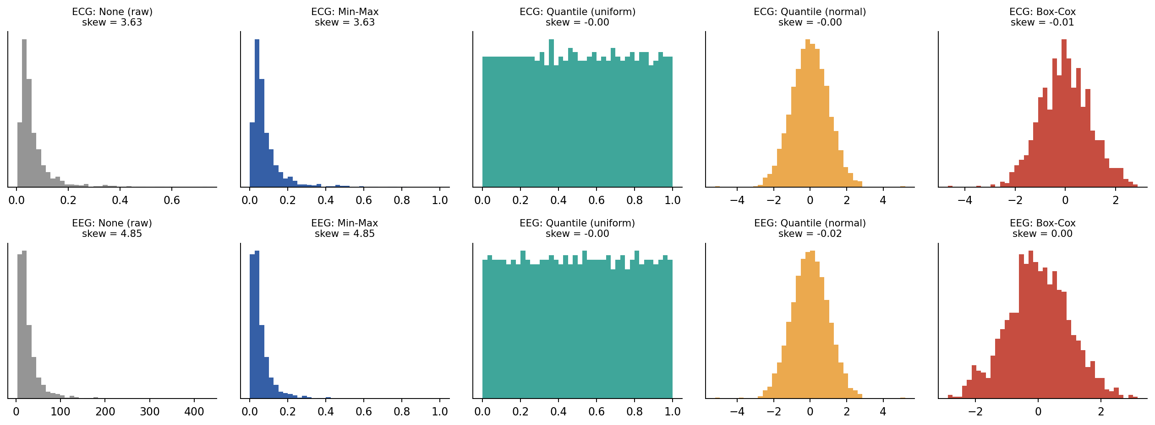
Figure 1: Distribution of one asymmetric feature (ECG HRV_RMSSD, EEG delta_power) before and after each scaling method.
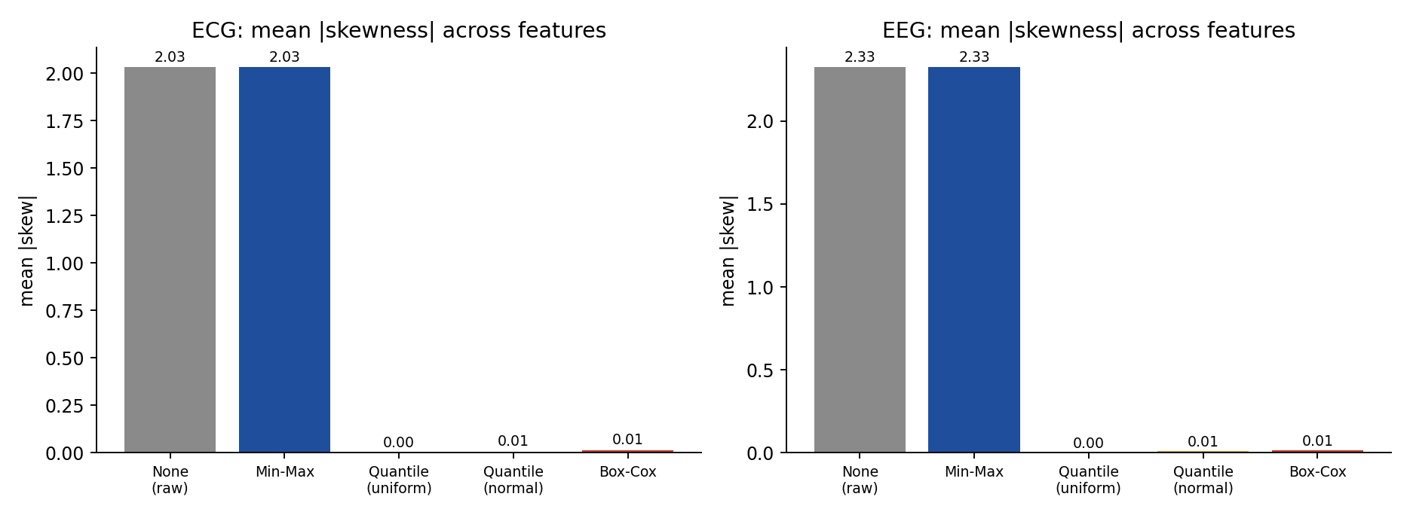
Figure 2: Mean absolute skewness of the feature sets under each normalization technique.
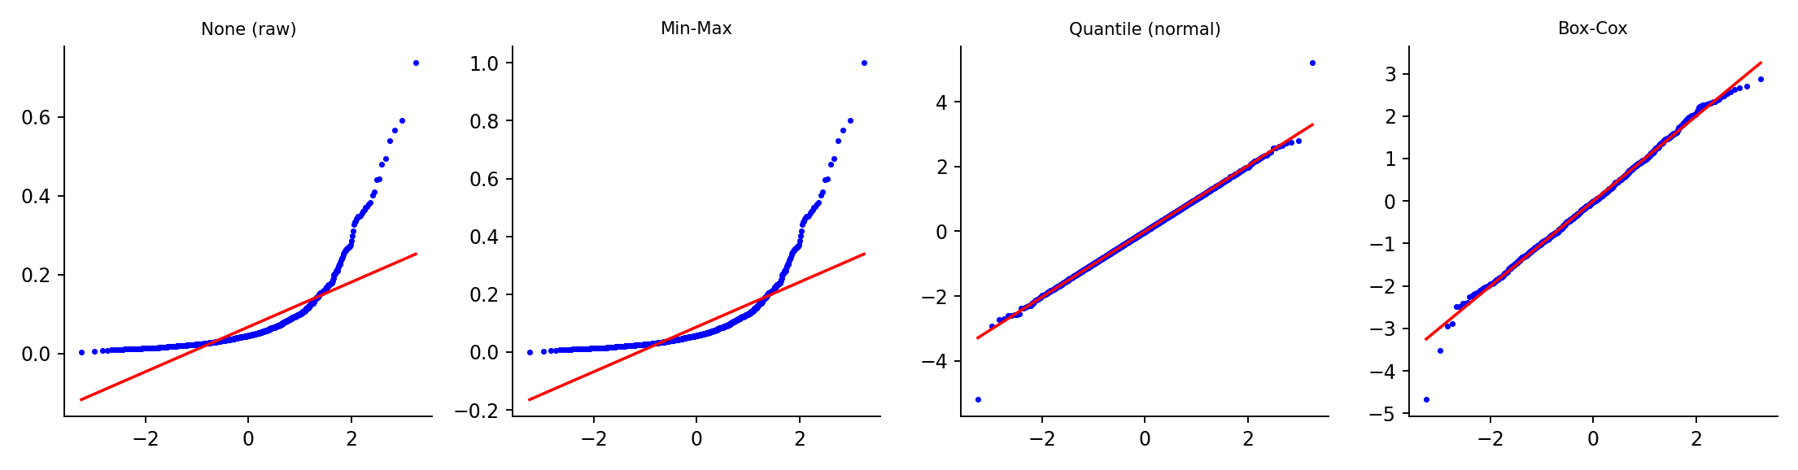
Figure 3: Normal Q-Q plots of ECG HRV_RMSSD for raw data, Min-Max, Quantile (normal) and Box-Cox; closeness to the diagonal indicates normality.
Table 2 lists the raw skewness of each feature and the Box-Cox λ fitted on the full set. Strongly skewed features (RR_std, HRV_RMSSD, Spectral_LF_HF, delta_power) obtained λ values well below one, consistent with a logarithm-like compression, while near-symmetric features such as QT_interval obtained λ close to or above one and were barely changed.
Table 2: Raw skewness and fitted Box-Cox λ per feature.
Signal | Feature | Raw skewness | Box-Cox λ
ECG | RR_mean | 0.70 | 0.515
ECG | RR_std | 3.55 | -0.220
ECG | QRS_width | 0.83 | 0.304
ECG | R_amp | 1.19 | 0.182
ECG | HRV_RMSSD | 3.63 | -0.200
ECG | QT_interval | 0.04 | 0.823
ECG | T_wave_amp | 2.18 | 0.259
ECG | Spectral_LF_HF | 4.14 | -0.135
EEG | delta_power | 4.85 | -0.172
EEG | theta_power | 3.29 | -0.076
EEG | alpha_power | 2.40 | 0.106
EEG | beta_power | 2.65 | -0.050
EEG | line_length | 1.82 | 0.169
EEG | kurtosis_raw | 2.37 | -0.266
EEG | spectral_entropy | -0.18 | 1.129
EEG | zero_cross_rate | 1.05 | 0.330

Table 3 reports the 5-fold cross-validated classification results. Without scaling, mean accuracy was 83.8% (ECG) and 83.6% (EEG); the SVM and KNN suffered most (for example, EEG KNN 79.7%), as expected for scale-sensitive learners, whereas Logistic Regression was comparatively robust (ECG 86.3%, EEG 88.1%). Every normalization method raised mean accuracy by about five to seven percentage points. Box-Cox attained the highest mean accuracy on both datasets (ECG 90.81%, EEG 89.08%), closely followed by Quantile (normal) (90.42% and 89.06%) and Min-Max (89.89% and 88.69%). The best single configuration was the Box-Cox + SVM-RBF pipeline on ECG at 93.1%, essentially tied with Min-Max + SVM (93.0%).
Table 3: Stratified 5-fold cross-validation accuracy (%, mean ± SD), plus mean accuracy and F1 across classifiers.
Signal | Method | LogReg | SVM-RBF | KNN (k=7) | Mean Acc. | Mean F1
ECG | None (raw) | 86.3 ± 1.9 | 83.3 ± 1.3 | 81.8 ± 1.0 | 83.81 | 73.69
ECG | Min-Max | 88.7 ± 2.3 | 93.0 ± 1.8 | 88.0 ± 2.4 | 89.89 | 84.13
ECG | Quantile (uniform) | 89.6 ± 1.8 | 91.8 ± 1.3 | 88.3 ± 1.5 | 89.92 | 85.14
ECG | Quantile (normal) | 89.8 ± 2.4 | 92.8 ± 1.9 | 88.7 ± 2.2 | 90.42 | 85.71
ECG | Box-Cox | 90.3 ± 1.6 | 93.1 ± 1.9 | 89.0 ± 2.3 | 90.81 | 86.18
EEG | None (raw) | 88.1 ± 2.0 | 82.9 ± 2.7 | 79.7 ± 1.5 | 83.56 | 78.54
EEG | Min-Max | 89.3 ± 2.6 | 89.8 ± 2.9 | 87.0 ± 2.6 | 88.69 | 85.69
EEG | Quantile (uniform) | 89.0 ± 2.4 | 89.2 ± 2.0 | 87.7 ± 2.3 | 88.64 | 86.05
EEG | Quantile (normal) | 89.4 ± 2.7 | 89.3 ± 3.1 | 88.4 ± 2.4 | 89.06 | 86.51
EEG | Box-Cox | 89.4 ± 3.0 | 89.7 ± 3.2 | 88.2 ± 2.5 | 89.08 | 86.55

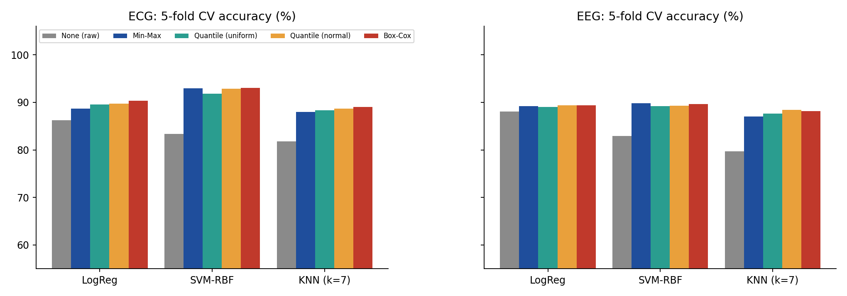
Figure 4: Cross-validated accuracy of each classifier under each normalization technique for ECG (left) and EEG (right).
Important caveat: the fold-to-fold standard deviation is about 1.3% to 3.2% for most configurations, which is larger than the 0.4 to 1.0 percentage-point differences among Min-Max, Quantile and Box-Cox. The distributional results are therefore decisive (Min-Max does not correct skew, the other two do), whereas the accuracy ranking among the three scaling families should be regarded as a tie within experimental error.
5. Conclusion and Future Scope
5.1 Conclusion:
This project compared Min-Max scaling, Quantile Transformation and Box-Cox power transformation on asymmetric ECG and EEG feature sets under a leakage-free protocol. The main findings are: (1) skewed physiological features should not be passed to classifiers unscaled, since scaling improved mean accuracy by 5 to 7 percentage points, with SVM and KNN benefiting most; (2) Min-Max scaling equalises ranges but leaves skewness (2.03 and 2.33) and the outlier tail untouched, which is why it remains vulnerable to artefacts; (3) Quantile Transformation and Box-Cox reduce skewness to below 0.02 and raise Shapiro-Wilk W to about 0.99, while retaining or slightly improving class separability; and (4) Box-Cox gave the highest mean accuracy on both datasets, but its margin over Quantile (normal) and Min-Max is within cross-validation noise. In practice, Box-Cox is a good default for strictly positive, smoothly skewed features because it is parametric, invertible and interpretable through λ, Quantile Transformation is preferable when features contain zeros, negatives, heavy outliers or multi-modal structure, and Min-Max is acceptable only after outlier clipping.
5.2 Future Scope:
- Real recordings: repeat the study on the MIT-BIH Arrhythmia Database and an annotated EEG corpus, using patient-wise (subject-independent) splits, since the present data are simulated and cannot capture inter-patient variability.
- More transformations: include Yeo-Johnson, robust (median/IQR) scaling and log transforms, which also cover zero and negative values.
- Statistical testing: apply repeated cross-validation with a Friedman test and Nemenyi post-hoc analysis to establish whether the accuracy differences among scalers are significant.
- MATLAB cross-validation: reproduce the Box-Cox and quantile routines in MATLAB to verify numerical agreement between the two environments.
- Deep learning: evaluate the effect of the same normalizations on convolutional and recurrent networks trained directly on signal windows or learned features.
6. References
- Andrzejak, R. G., Lehnertz, K., Mormann, F., Rieke, C., David, P., & Elger, C. E. (2001). Indications of nonlinear deterministic and finite-dimensional structures in time series of brain electrical activity: Dependence on recording region and brain state. Physical Review E, 64(6), 061907.
- Box, G. E. P., & Cox, D. R. (1964). An analysis of transformations. Journal of the Royal Statistical Society: Series B, 26(2), 211–252.
- Goldberger, A. L., Amaral, L. A. N., Glass, L., Hausdorff, J. M., Ivanov, P. Ch., Mark, R. G., Mietus, J. E., Moody, G. B., Peng, C.-K., & Stanley, H. E. (2000). PhysioBank, PhysioToolkit, and PhysioNet: Components of a new research resource for complex physiologic signals. Circulation, 101(23), e215–e220.
- Harris, C. R., Millman, K. J., van der Walt, S. J., et al. (2020). Array programming with NumPy. Nature, 585, 357–362.
- Hastie, T., Tibshirani, R., & Friedman, J. (2009). The Elements of Statistical Learning: Data Mining, Inference, and Prediction (2nd ed.). Springer, New York.
- Hunter, J. D. (2007). Matplotlib: A 2D graphics environment. Computing in Science & Engineering, 9(3), 90–95.
- Jain, A., Nandakumar, K., & Ross, A. (2005). Score normalization in multimodal biometric systems. Pattern Recognition, 38(12), 2270–2285.
- Moody, G. B., & Mark, R. G. (2001). The impact of the MIT-BIH Arrhythmia Database. IEEE Engineering in Medicine and Biology Magazine, 20(3), 45–50.
- Pedregosa, F., Varoquaux, G., Gramfort, A., et al. (2011). Scikit-learn: Machine learning in Python. Journal of Machine Learning Research, 12, 2825–2830.
- Peterson, R. A., & Cavanaugh, J. E. (2020). Ordered quantile normalization: A semiparametric transformation built for the cross-validation era. Journal of Applied Statistics, 47(13–15), 2312–2327.
- Sakia, R. M. (1992). The Box-Cox transformation technique: A review. The Statistician, 41(2), 169–178.
- Singh, D., & Singh, B. (2020). Investigating the impact of data normalization on classification performance. Applied Soft Computing, 97, 105524.
- Task Force of the European Society of Cardiology and the North American Society of Pacing and Electrophysiology (1996). Heart rate variability: Standards of measurement, physiological interpretation, and clinical use. Circulation, 93(5), 1043–1065.
- Virtanen, P., Gommers, R., Oliphant, T. E., et al. (2020). SciPy 1.0: Fundamental algorithms for scientific computing in Python. Nature Methods, 17, 261–272.
- Yeo, I.-K., & Johnson, R. A. (2000). A new family of power transformations to improve normality or symmetry. Biometrika, 87(4), 954–959.

